**TAMIL TEXT TO ENGLISH EMOTIONAL SPEECH CONVERSION WITH UNL FOR TRANSLATION**

B.ARCHANA - 2011103505

M.R.SIVA - 2011103536

R.JAYAVASANTH-2011103562

**Project Guide : Dr. Rajeswari Sridhar**

**Asst. Professor (Sr. Grade)**

**Department of Computer Science and Engineering,**

**Anna University, Chennai - 25**

**Introduction:**

This project in the field of Natural Language Processing aims at translating an input Tamil sentence into an equivalent spoken English translation of the sentence. This brings together two major domains in NLP, i.e, machine translation and TTS (Text to Speech). Natural Language Processing is the field of computer science that deals with interactions between computer and human languages. One of the aims of NLP is “Natural Language Understanding”, i.e., to enable computers to derive meaning from human language input. Computational linguistics is a sub domain under NLP, which focuses specifically on language related work such as language modelling, representation. Machine Translation is one such field of computational linguistics. Machine Translation involves the development of software for translation of given text from a source language to the target language.

**Problem Statement:**

Given a Tamil sentence as input, the project will translate it into its corresponding English sentence with no loss in meaning while preserving the semantic structure of English. The translated sentence would be voiced over with a humanised robotic voice. Given a batch of sentences (document input), each sentence would be processed and translated and synthesised into speech with emotion.

The first phase of the project i.e, conversion of Tamil input text into English is done by converting Tamil text into the Universal Networking Language representation and then converting from UNL into the equivalent English form. Here UNL is used as the pivot language in between the Tamil and English languages. Since, UNL is language-independent, it offers a very flexible platform for the representation of knowledge and thus gives great scope for research, in conjunction with the rich language of Tamil, that we have undertaken in our project. The second phase of our project takes the converted English text and processes it with a Text-To-Speech Engine, to convert it into speech. This TTS system is modified at signal level so as to incorporate emotion, to make the robotic speech more humanized. The given text is transformed into speech with the necessary prosody, stress and intonation marked so as to add emotion to the text.

**TOP LEVEL BLOCK DIAGRAM:**

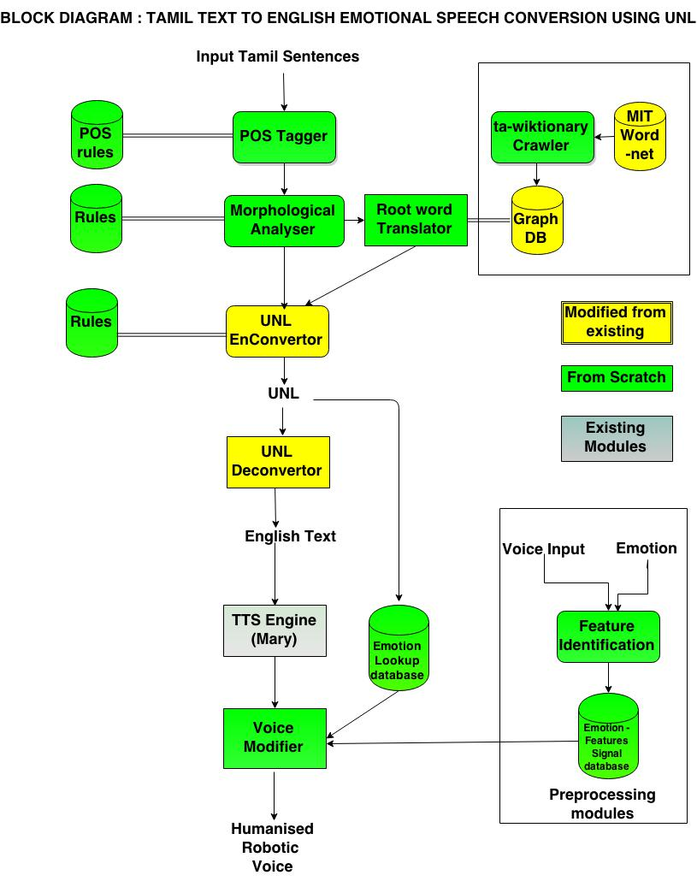

**MODULES SPILT-UP:**

* **OFFLINE PHASE**
  + WordNet Construction - Siva, Jayavasanth
  + Emotion-Signal Database - Archana

Construction

* **ONLINE PHASE**
  + Morphological Analyzer - Siva
  + POS tagging - Siva
  + UNL Enconversion - Jayavasanth
  + UNL Sub-graph Identification - Jayavasanth
  + UNL De conversion - Jayavasanth
  + Emotion Identification - Archana
  + Voice Modification & Output - Archana

**GANTT CHART:**

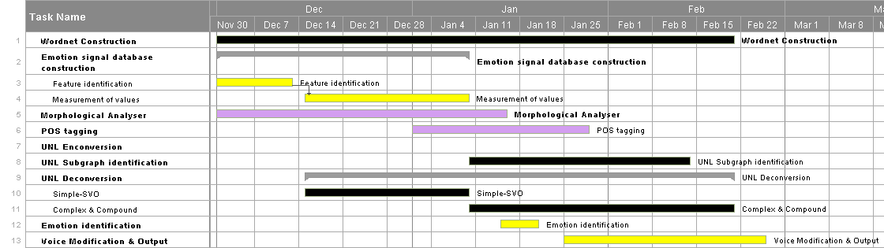

**REFERENCES:**

[1] Sudhakar Sangeetha, Sekar Jothilakshmi, “Syllable based text to speech synthesis system using auto associative neural network prosody prediction”, In International Journal of Speech Technology, Vol-17, Issue-2, pp 91-98, 2014.

[2] Dave S., Parikh J. and Bhattacharyya P., ”Interlingua Based English Hindi Machine Translation and Language Divergence, Machine Translation”, Journal of Machine Translation, Volume 16, pp.251-304, 2001.

[3] Tristan Bowles, Sandra Pauletto, “Emotions in the Voice: Humanising a Robotic Voice.” Proceedings of the 7th Sound and Music Computing Conference, Barcelona, Spain, 2010.

[4] Dhanalakshmi V., Anand kumar M., Soman K. P. and Rajendran S., ”Postagger and Chunker for Tamil Language”, Proceedings of the 8th Tamil Internet Conference, Cologne, Germany, 2009.

[5] Rajeswari Sridhar, Sugadev C, Mani Murugesan P, Vignesh N T, ”A hybrid approach to Tamil Morphological generation”, 13th International Tamil Internet Conference, pp 101- 105, Pondicherry, 2014.

[6] T. Dhanabalan, K. Saravanan & T.V. Geetha, "Tamil to UNL EnConverter" , Proc. International Conference on Universal Knowledge and Language, Goa, India, 2002.

[7] J Balaji, T V Geetha, Ranjani and Madhan Karky, "Morpho-Semantic Features for Rule-based Tamil Enconversion", International Journal of Computer Applications 26, pp 11-18, July 2011.

[8] Balaji J, Geetha T V, Ranjani Parthasarathi, “Semantic Parsing of Tamil Sentences”, Proceedings of the Workshop on Machine Translation and Parsing in Indian Languages (MTPIL-2012), pp 15–22, COLING 2012, Mumbai, December 2012.

[9] Jayavasanth R ,Rajeswari Sridhar “A hybrid approach to construction of Wordnet ” 13th Tamil Internet Conference, International Forum for Information Technology in Tamil, Pondicherry, pp-120, 2014.

[10]Lin, Chin-Yew and Franz Josef Och. “Automatic Evaluation of Machine Translation Quality Using Longest Common Subsequence and Skip-Bigram Statistics”, In Proceedings of the 42nd Annual Meeting of the Association for Computational Linguistics (ACL 2004), Barcelona, Spain, July 21 - 26, 2004.

[11] Mumtaz, B., "Adding an Emotions Filter to Malay Text-to-Speech System", Master Thesis, University of Malaya, Malaysia, 2006.

[12] Pierre-Yves Oudeyer , “The production and recognition of emotions in speech: features and algorithms” , ” International Journal of Human Computer interaction, 59, pp 157–183, 2003.

FINAL DEMONSTRATION:

Given the input as a Tamil sentence, the final output will be an emotional voice that speaks the English translation of the input sentence.

**(Dr. Rajeswari Sridhar)**